**Todo APIs Document**

**Root URL:** <http://localhost:3000/>

**Get TodoList**

Endpoint: /api/v1/todoList

Method: GET

Parameter: -

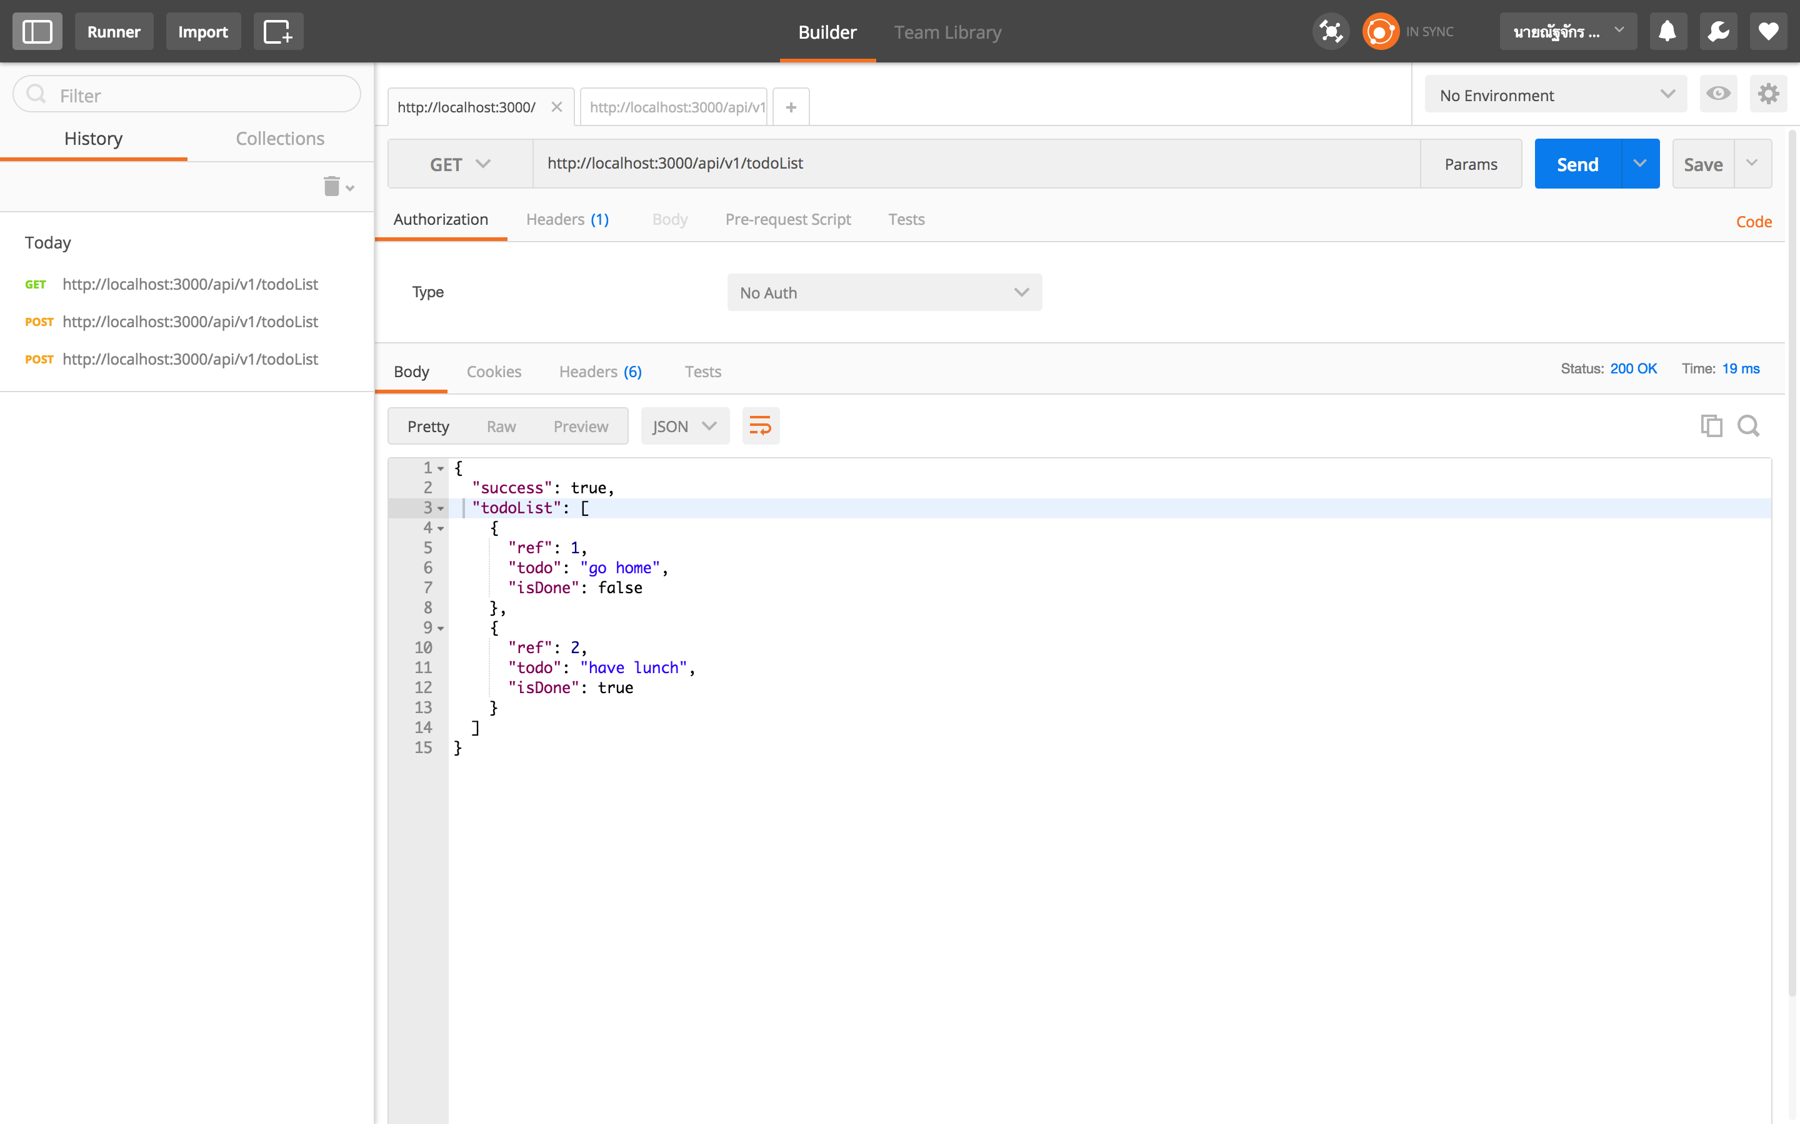

**Get Todo with Ref code**

Endpoint: /api/v1/todoList/{:ref}

Method: GET

URL Parameter:

* ref: Number

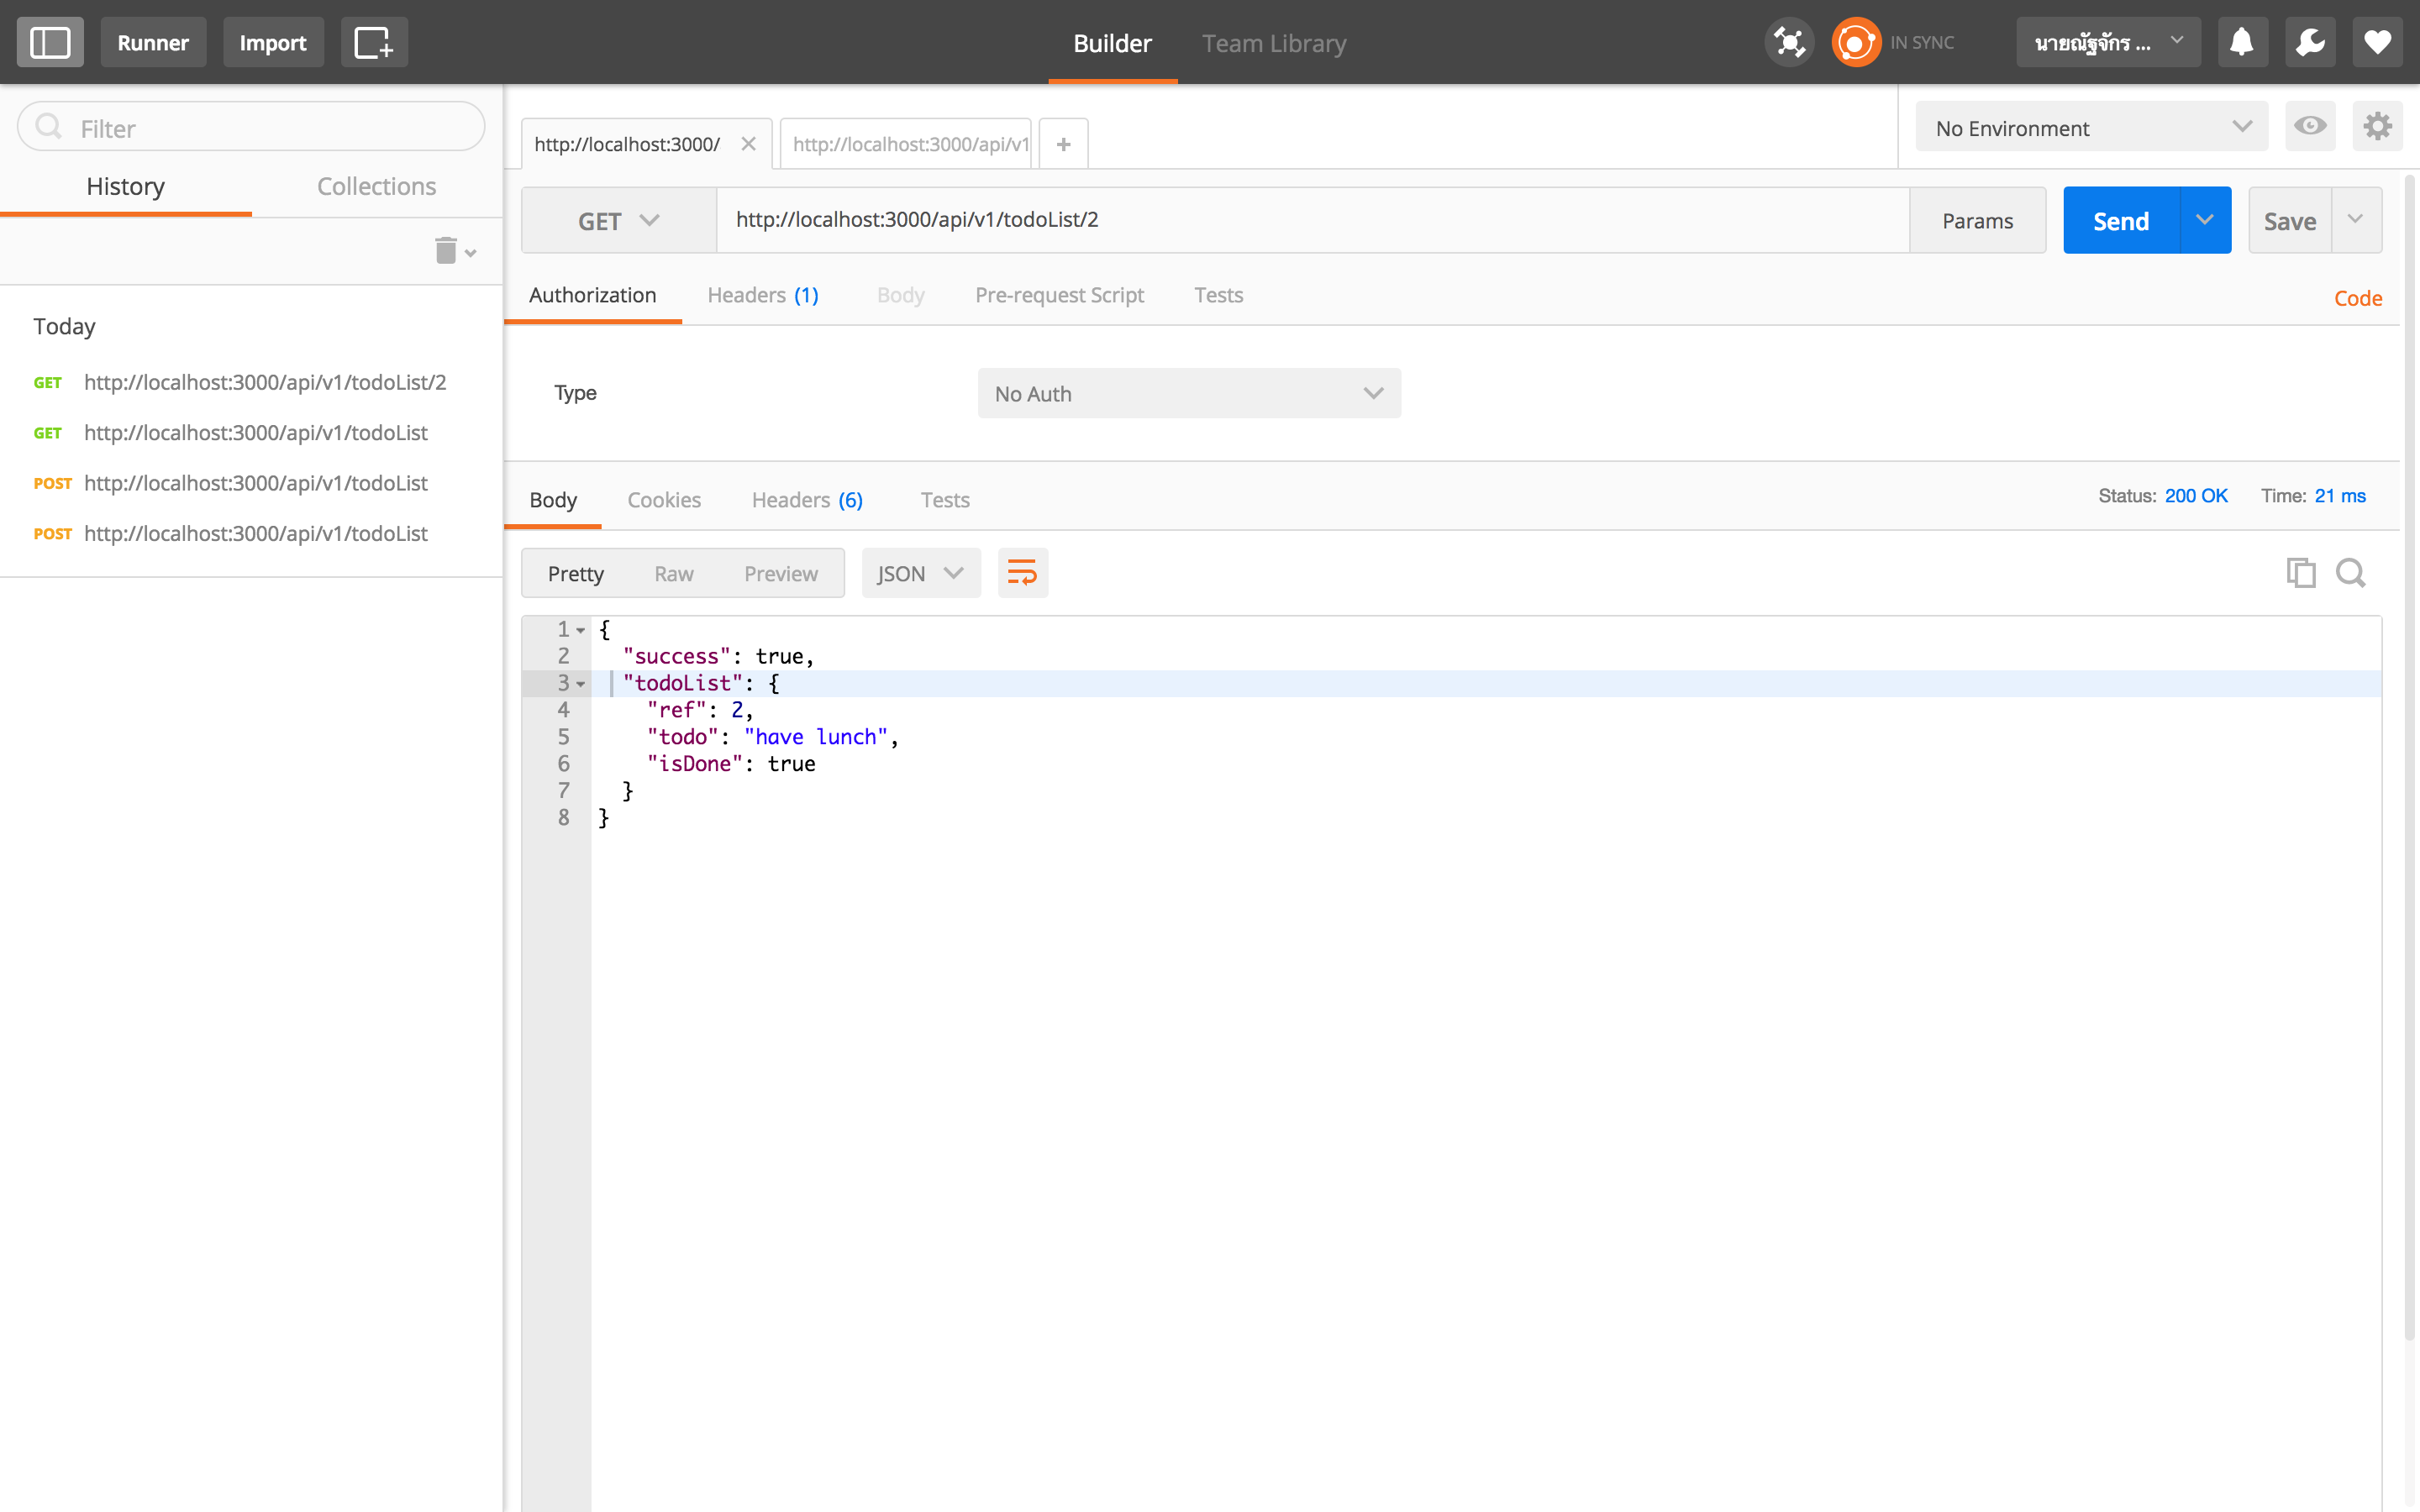

**Add Todo**

Endpoint: /api/v1/todoList

Method: POST

Body Parameter:

* todo: String
* isDone: Boolean

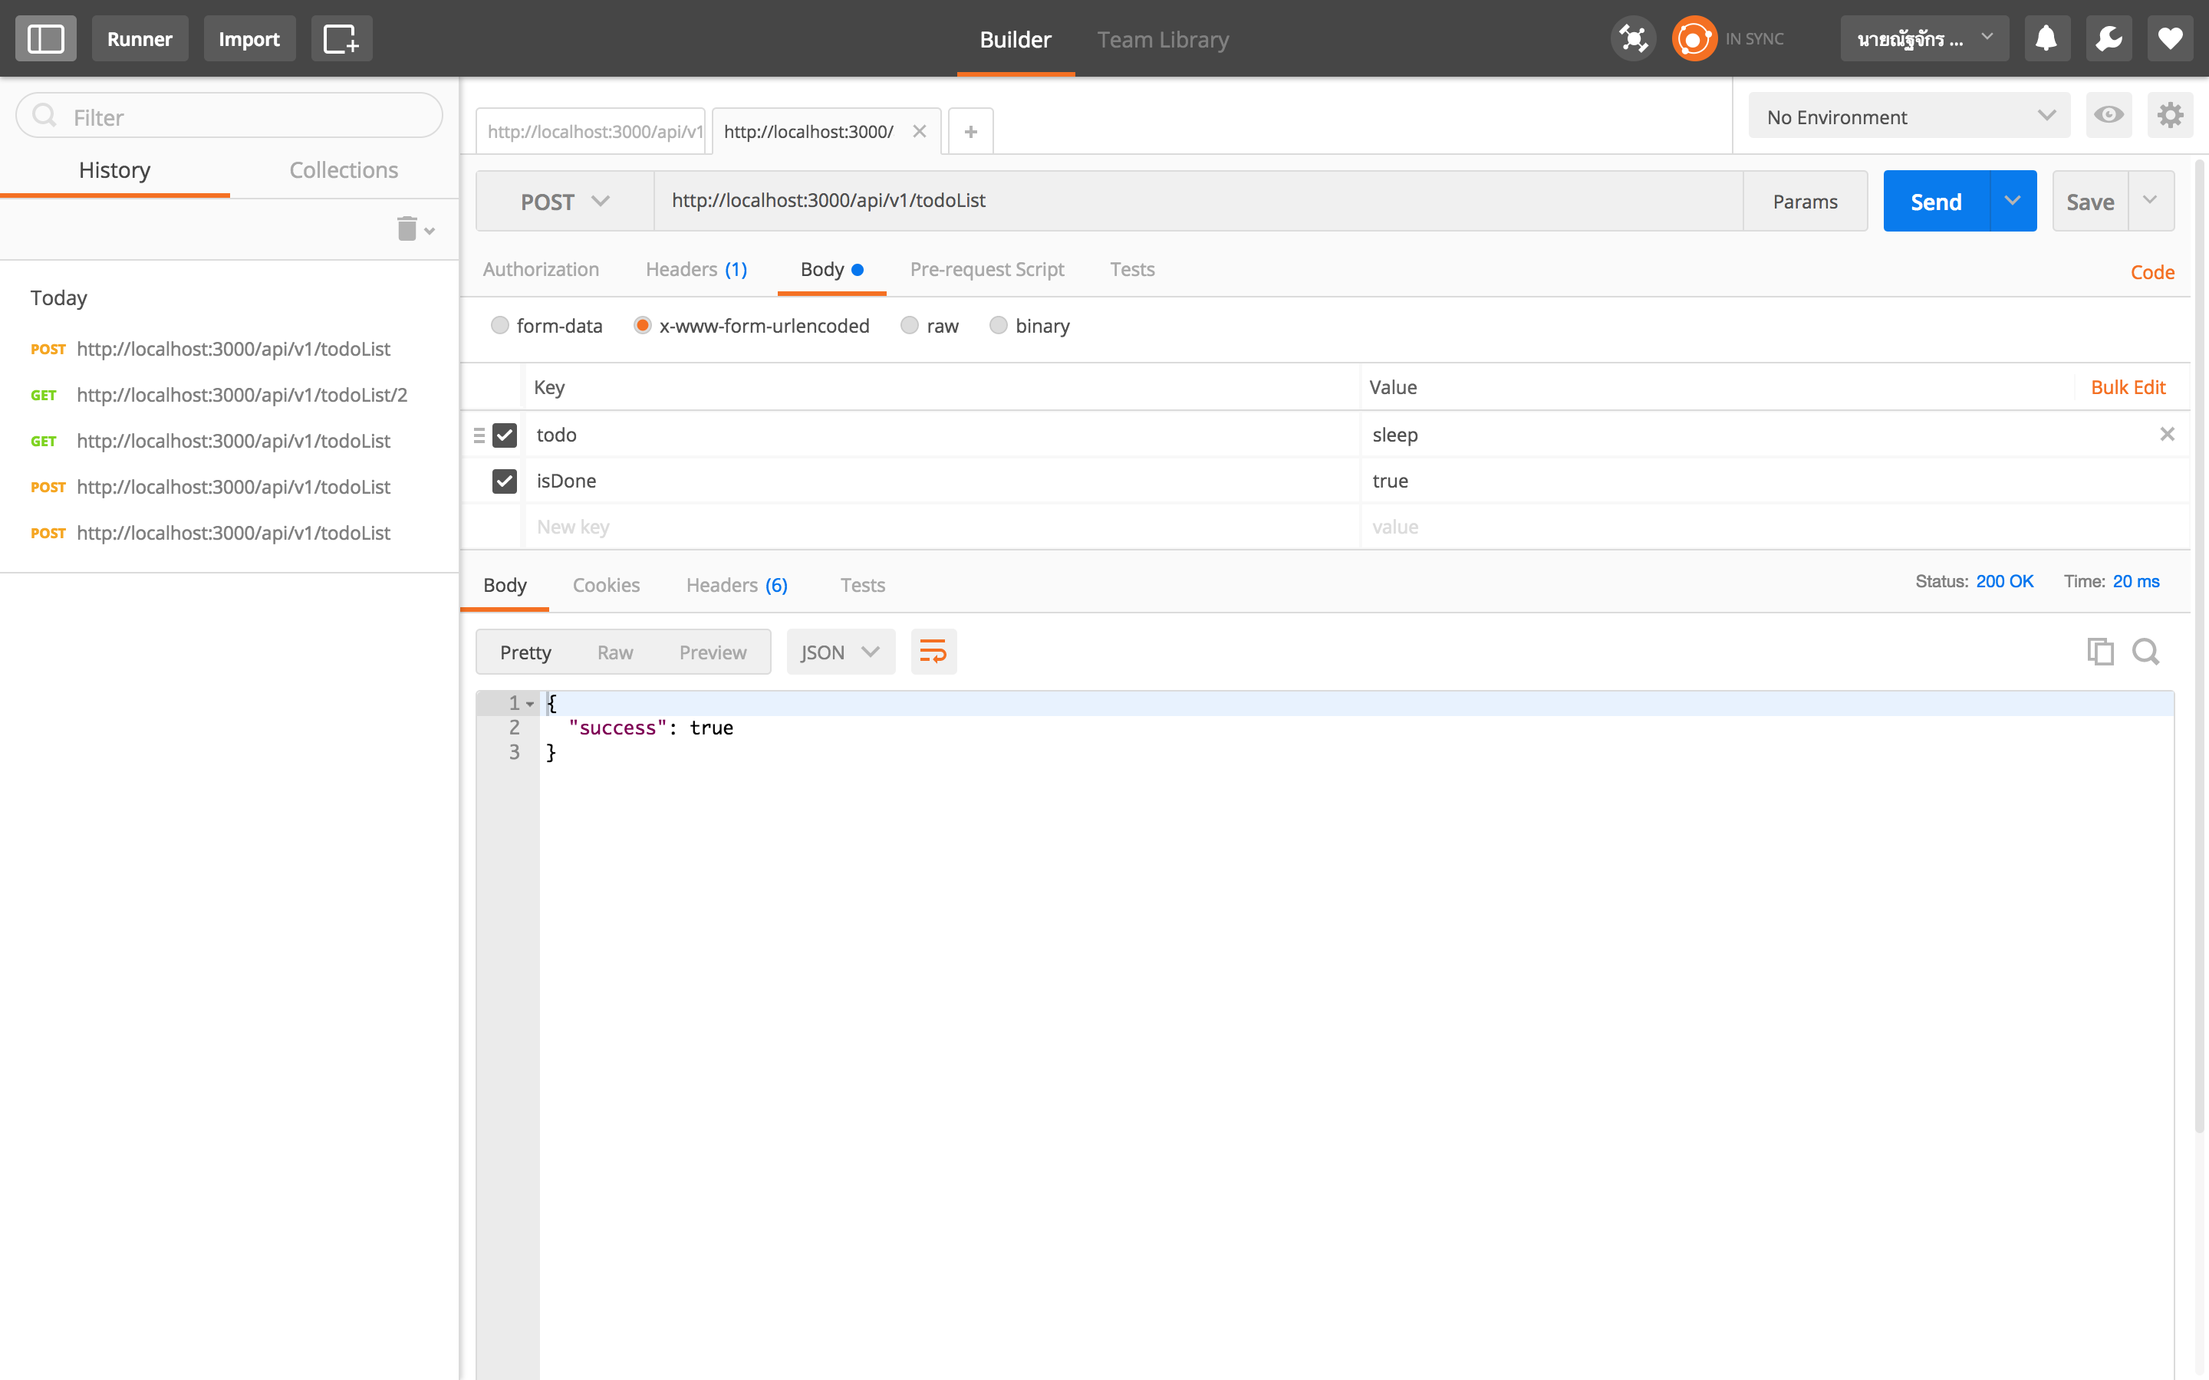

**Edit Todo with Ref code**

Endpoint: /api/v1/todoList/{:ref}

Method: PUT

URL Parameter:

* ref: Number

Body Parameter:

* todo: String
* isDone: Boolean

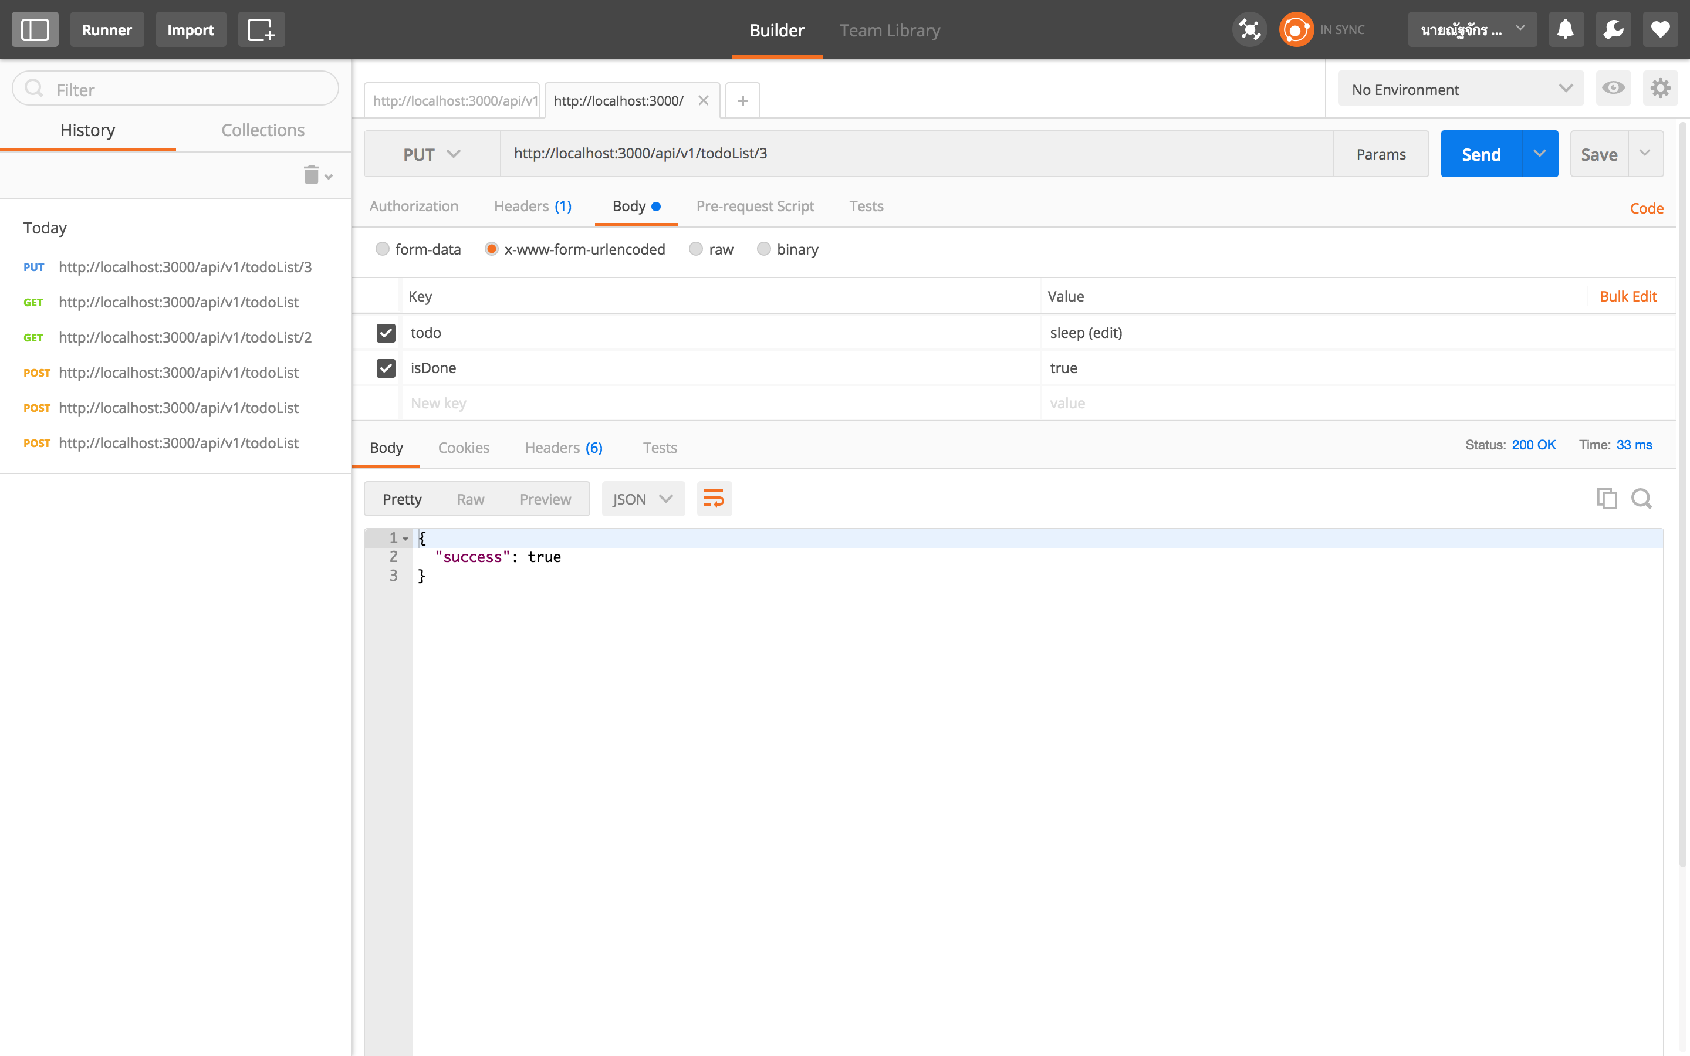

**Edit isDone with Ref code**

Endpoint: /api/v1/todoList/{:ref}

Method: PATCH

URL Parameter:

* ref: Number

Body Parameter:

* isDone: Boolean

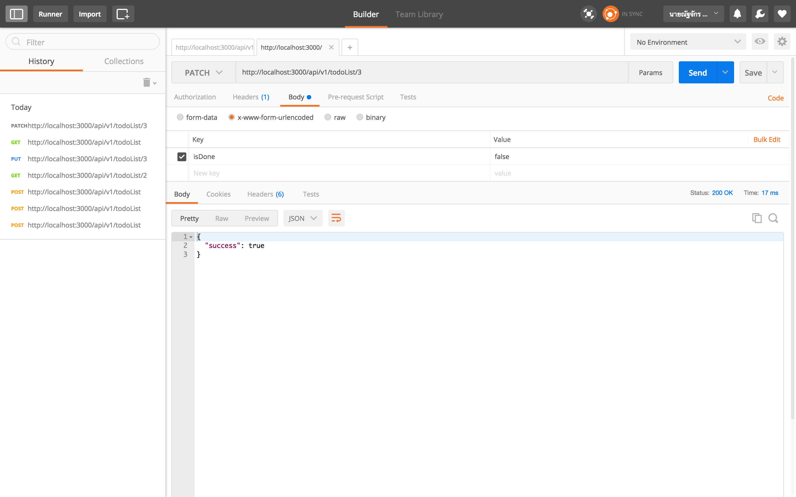

**Delete Todo with Ref code**

Endpoint: /api/v1/todoList/{:ref}

Method: DELETE

URL Parameter:

* ref: Number

